**Name:**

The Boston Lagers

**Title:**

Analyzing Trends in Uber and Lyft Data

**Team Members:**

Aaron Schwartzman, Benji Hawkins, David Seger, Rachidi Ndongala

**Question 1: How do ride distance and ride price compare across the various ride sources?**

Prior to analyzing the data related to this question, it is important to know the relative locations of the 12 regions included in the sample area. The following figure is adapted from a figure produced by the creators of the original dataset. Each zone is labelled with the exception of the Theatre District, which is the small region south of Beacon Hill.

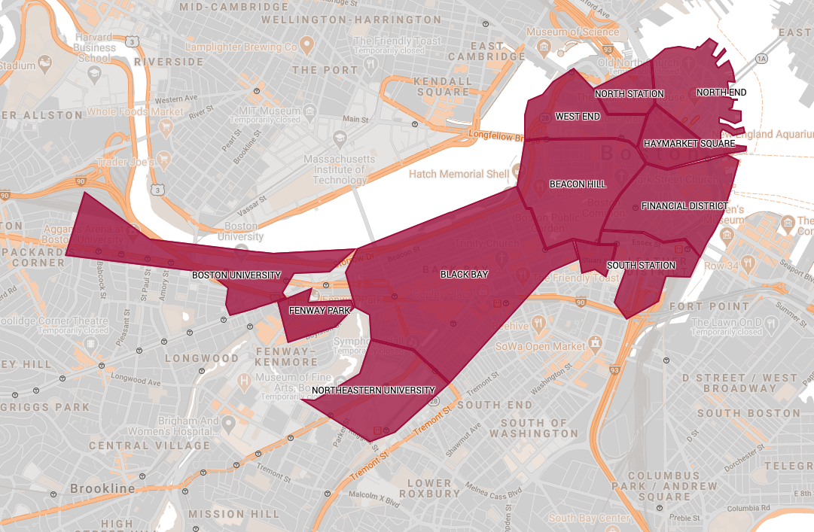

Now, to answer the original question, two figures were produced. The first shows the average ride distance grouped by source, and the second shows the average ride price grouped by source.

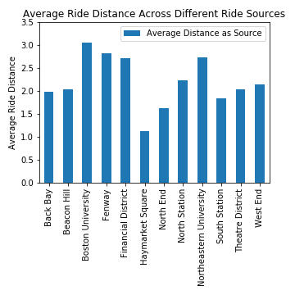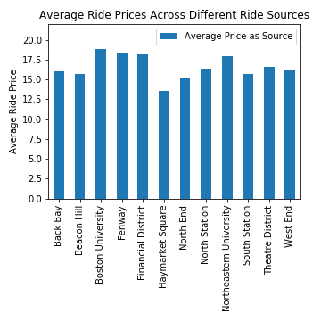

Through our analysis, we found that the longest and priciest Uber and Lyft rides tended to originate from one of four locations: Boston University, Fenway, Northeastern University, and the Financial District. One explanation for this observation is the fact that Boston University, Fenway, and Northeastern University are located on the Western edge of the sample area. Meanwhile, the Financial District is located on the Eastern edge. Furthermore, from the figure provided below, we know that the Financial District is the most common ride origin.

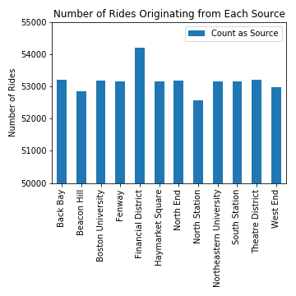

Given the distance between the Western edge and the Financial District, frequent travel between these areas could inflate their respective average ride distances.

In contrast, the locations from which the shortest and cheapest rides originated were Haymarket Square and North End. Once again looking at the map of Boston, we see that Haymarket Square and North End are located in the Northeast corner of the sample area. More importantly, however, they are very close to the Financial District, which has been seen to act as a sort of hub for ride-sharing in Boston. We can make the hypothesis that the shortness of rides originating at Haymarket Square and North End occurs because individuals are more likely to travel to the Financial District than any other location, and Haymarket Square and North End are very close to the Financial District.

**Question 2: How do ride distances and prices compare between Uber and Lyft services?**

One would think with Uber being the “premier” and largest ride share service that it would also be the most expensive. Analysing the data and looking at the grid below you will notice that **Fare Per Mile** for Lyft $7.93 vs Uber $7.21 and the **Average Fare Per Trip** Lyft is $1.50 higher than Uber. The **Total Trips** in Boston Lyft is also the leader and based on this data Lyft would appear to be the most popular ride share service in Boston.

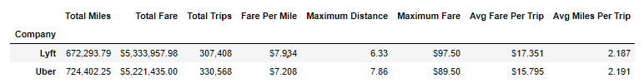

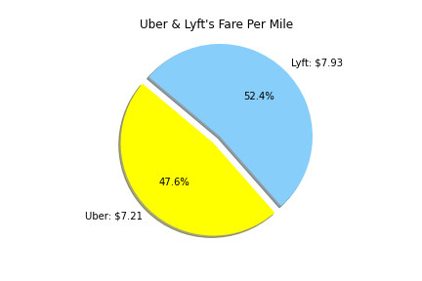

So to analyze the data a scatter plot was created for each of the services comparing distance in miles to fares in dollars. The Lyft scatter plot shows that there really is no distinct raise in fares until you get to the 6 mile marker which really emphasizes the value pricing that you can get with Lyft.

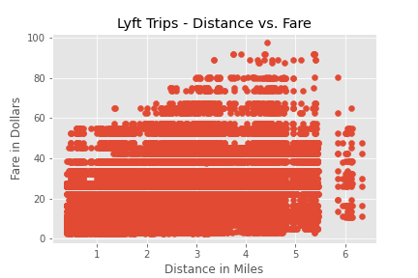

If you look at the Uber scatter plot below the minimum fare price consistently rises the further you go.

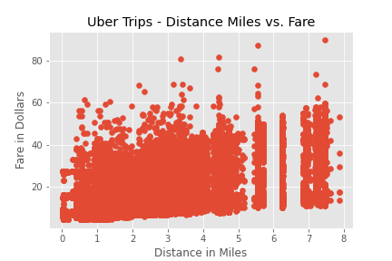

There is one distinction between the dataset the was analyzed is that Lyft reported “surge pricing factor” which was not reported by Uber. This peak pricing model is a factor in the overall results for

**Question 3: Can we group timestamps by day of the week and find trends between ride price and day of the week?**

By going through the data and trying to pull the trends between the price ride and the day of the week, we found that most of the people used the ride share on Wednesday, Thursday, Friday, Saturday and Sunday. The ride was not busy on Tuesday.

Talking about the price, we all know Uber as the premier and largest ride share in the worldwide and going through the data, we found out that Lyft price was slighting higher than Uber’s price. And that is the reason why most of the travelers choose Uber in the long distances and Lyft in the short distance.

Based on the analysis we did on our data; the plot bar was created for the Uber distance ride and the plot line was also created for the Lyft distance ride to show the sum of the distance and price on each day of the week.

